This document discusses about the way to create new window in the Adempiere.

- In Adempiere each database table represents a tab in window . Window can contain one or more tabs. Let us say we want to add/update patient details in new window in the Adempeire, we need to create the corresponding table.

2. Let us say we want to take patient name, doctor name, patient age, phone no of the patient from window then we need to create the following table. Each Adempiere custom table should in default contain the ad_client_id, ad_org_id, isactive, created, createdby, updated , updatedby, name, value fields. Adempiere convention is to have table name appended with “_id” as the primary key to the table. So add c_patient_details_id as column in the table.

CREATE TABLE adempiere.c_patient_details (
c_patient_details_id numeric(10,0) NOT NULL,
ad_client_id numeric(10,0) NOT NULL,
ad_org_id numeric(10,0) NOT NULL,
isactive character(1) DEFAULT 'Y'::bpchar NOT NULL,
created timestamp without time zone DEFAULT now() NOT NULL,
createdby numeric(10,0) NOT NULL,
updated timestamp without time zone DEFAULT now() NOT NULL,
updatedby numeric(10,0) NOT NULL,
"value" character varying(30) NOT NULL,
"name" character varying(255) NOT NULL,
patient_name character varying(30) ,
refered_doctor character varying(30),
age_of_patient numeric(3,0),
phone_no numeric(10,0) );

  - Create this table in the database you are using and check whether the table is created.

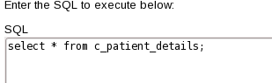
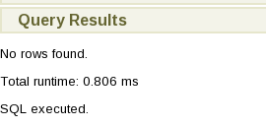
Table successfully created, as expected there are no rows in the table.
  - Once table is successfully created, login into Adempiere as System/System and select the role as System Adminstrator, then login into system
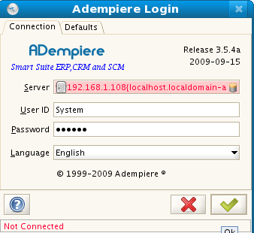
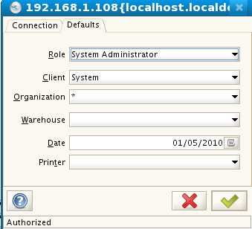

  - Then on the right side of window, there is application directory click on “Window,Tab & Field”.

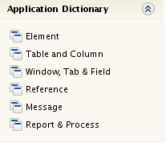

  - Then on the right side of window, there is application directory click on “Table and Column”.
  - Click on new logo, which is right lower end of the window, then you see the following window. In DB table name enter the proper name of the table you created. Enter the data in fields as it is shown in window.

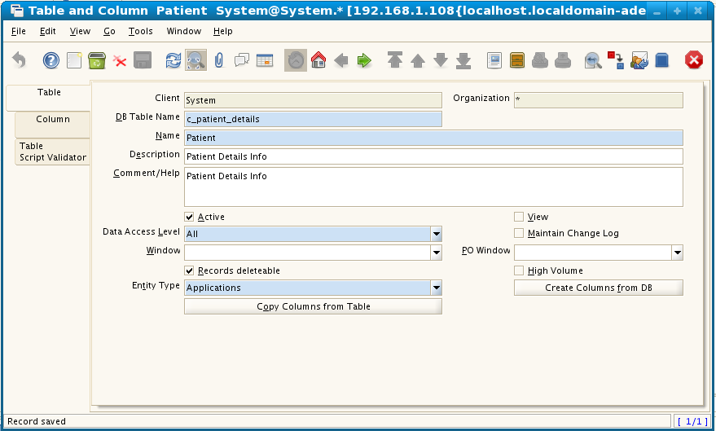
  - Then click on the “Copy Columns from table” button and you see the following window
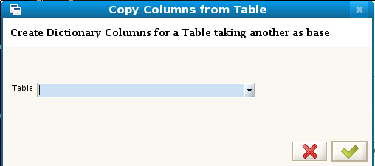

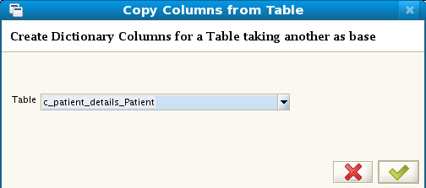

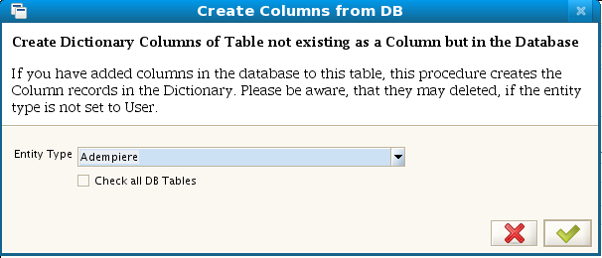

  - Then click on “Create Columns for DB” tab and select adempiere

  - Then you will see the following window.

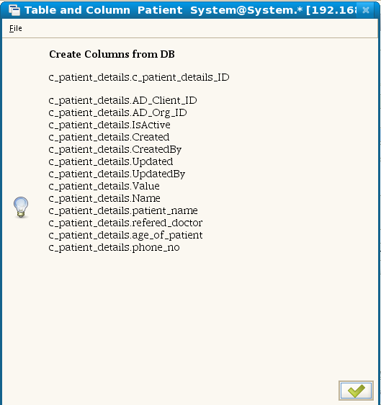

  - Click on tab columns and you see the list of columns populated. With this step we created table infomation into adempiere strcuture, now we need to create window for this table
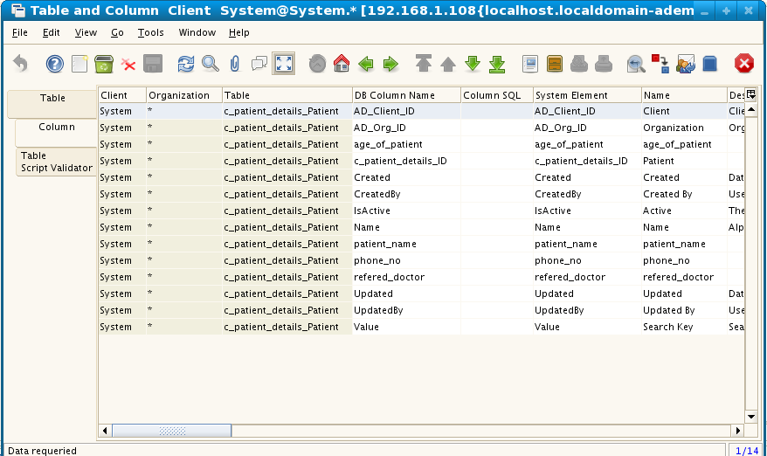

  - Click on new logo, which is right lower end of the window, then you see the following window.
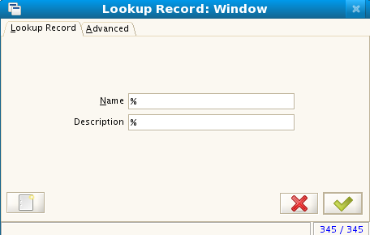

  - Then you see the following details, Here we create the window we need by using the table we newly created. Make sure window width and height is null. Do the selection same way it seleted in below window.
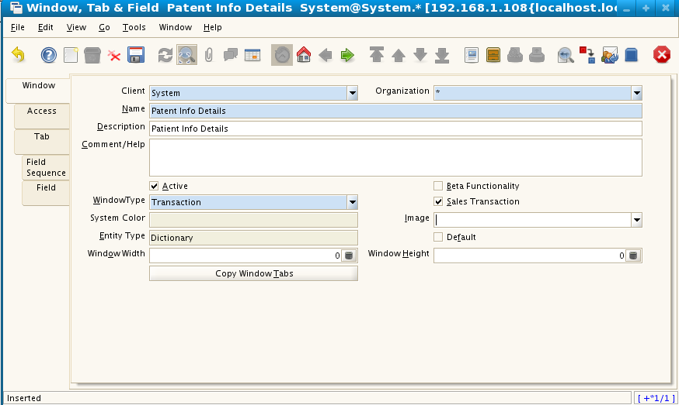
  - Affter entering click on “Tab” tab which is right side of window and click on new logo. Select the table as our new table.
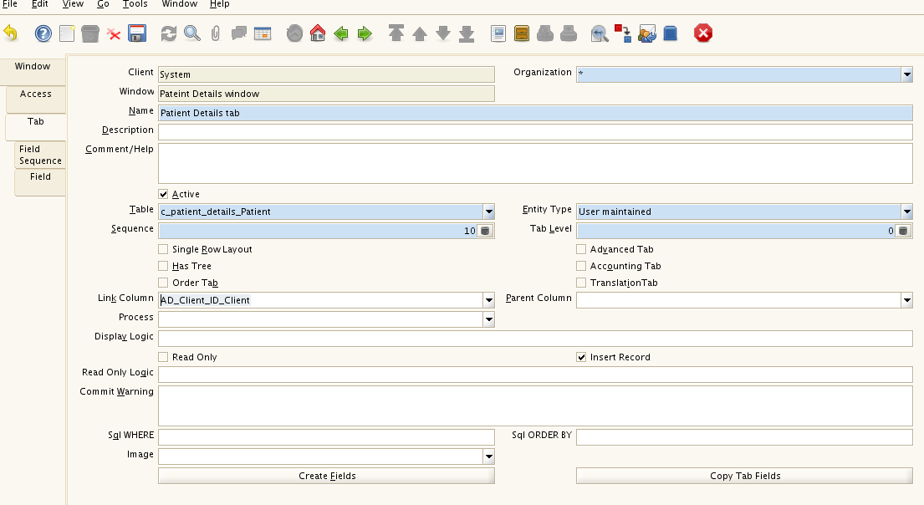

  - Then click on Create Fields button, then you see the following window, then click on OK
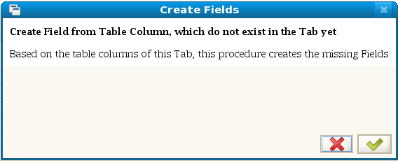

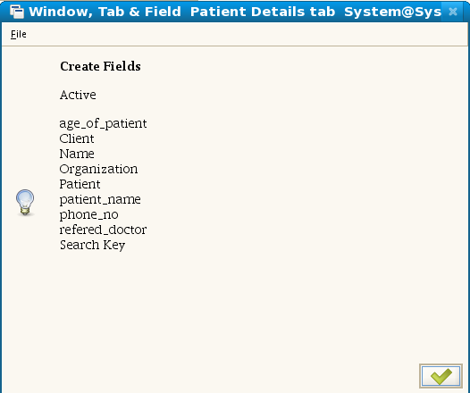

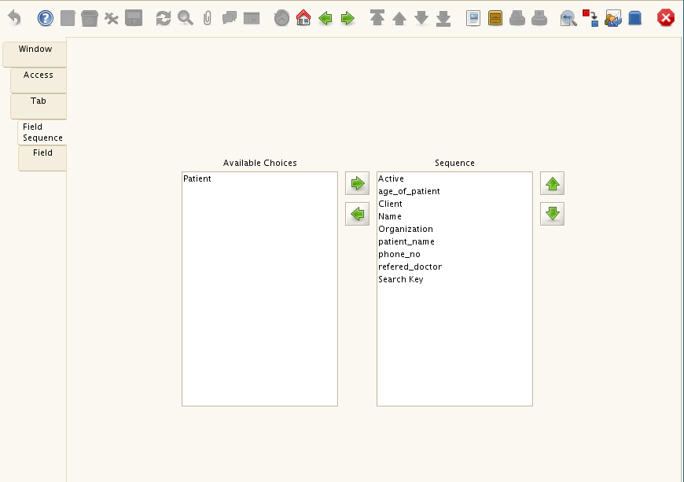
  - Then click on Field Sequence tab, you the list of coulmns in the tab, with this step we completed the creation of window. Now we want to add window to menu.

  - Then select “System Admin”, “General rules”, 'System Rules” and then click on “Menu”, you see the following window.
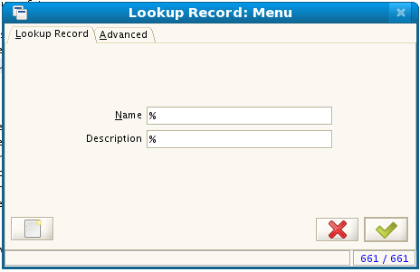
  - Then click on new item,you get the following screen. 'Action' is drop down button so select window,it creates a new drop down list “Window”, then select our new window there and save it.

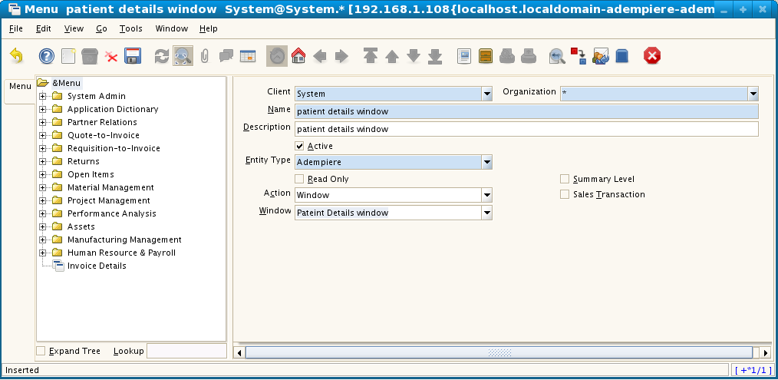

  - Then you see our patient details window, on right hand of the window
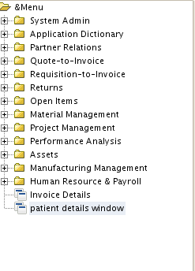

  - After logging in as SirijaProdOrg user you see the following screen
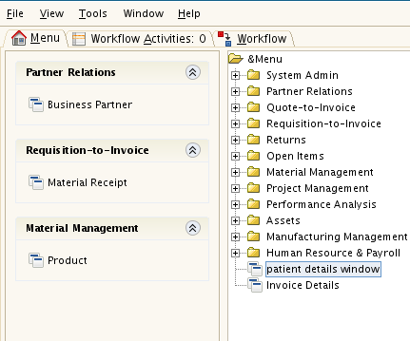

  - Click on patient details window and create the patient details.

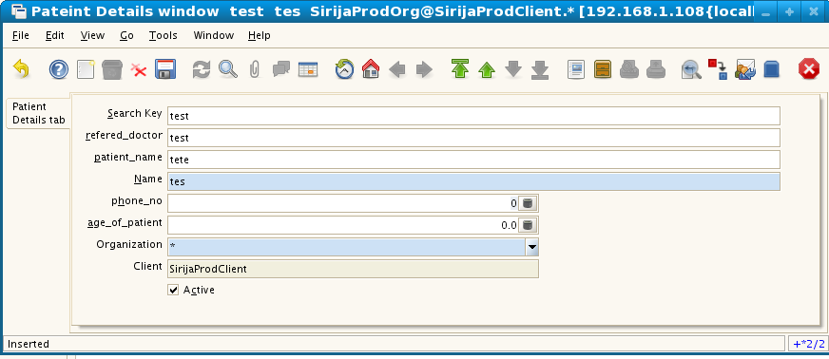

  - Then next is to format to report the gets generated from the this window, then click on form
which is at top of window
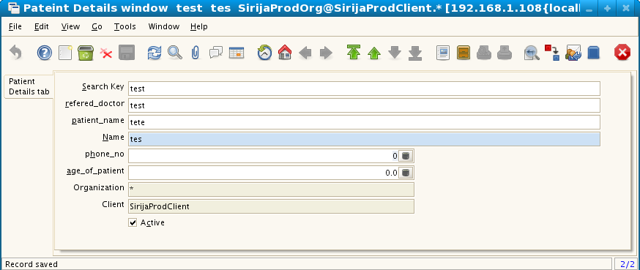

  - Then you will the see the following screen

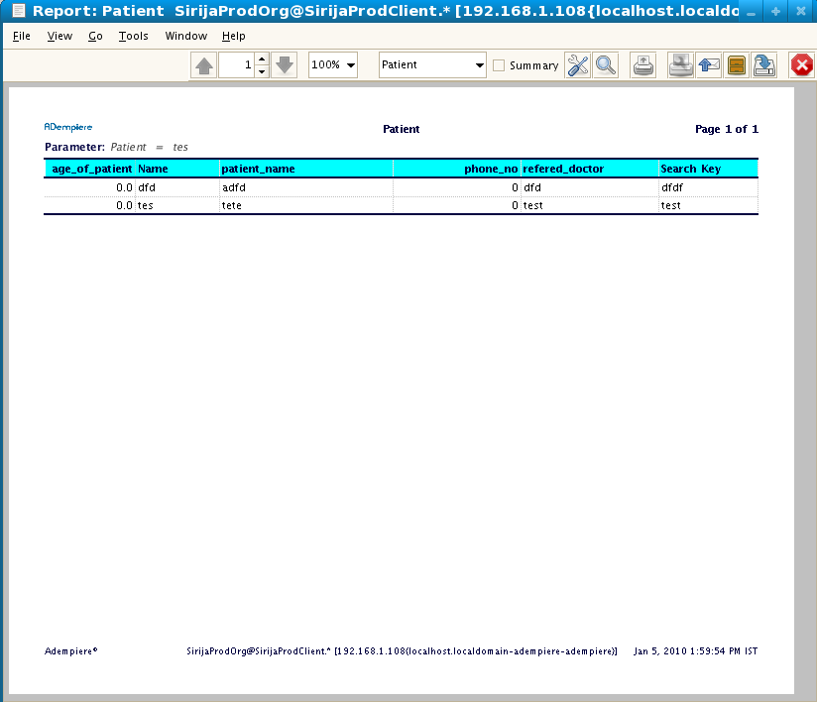
  - Then as per client requirement we don't want to see the pateint age in the report. We see the following tap bar on the window
Click on chnage tab
  - Then you see the following window

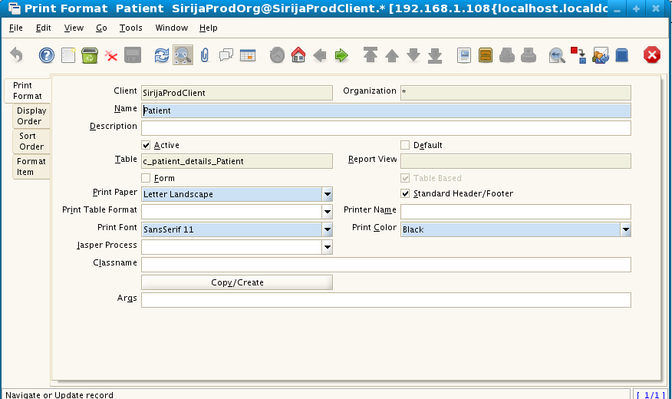
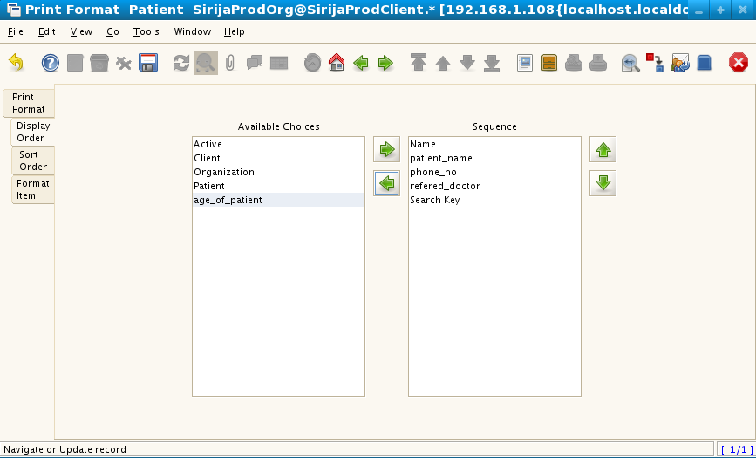
  - Then click on the Display Order and move age_of_pateint to left screen

  - Now click on report, then you do not see the patient_age
